Natalie Huber

Mike Muehlbradt

LAB 3.3

**Site Evaluation Protocol:**

1. **White space / Semantic spacing**

The white space down the middle of the page is extremely awkward because it joins the paragraphs on the left side with the paragraphs on the right side. It’s not visually appealing, nor is it easy to navigate and read. I would recommend they space the paragraphs much farther apart.

1. **Consistency**

I did not find this International Glaucoma Associations very consistent due to their variations in languages. It doesn’t make sense to have multiple languages on the same page saying the exact same thing. If you were using a screen reader, I can imagine you would very confused. I suggest there, instead be an option to choose your language and then only make visible the chosen language.

1. **Density / Clutter**

On the menu bar on the left, there are options to change your language, and then directly underneath it, there are different type of glaucoma and symptoms listed. To me, this does not seem like these options should be in the same menu bar. Instead I would suggest creating a landing page when you enter the site to choose your language, then I would have a home page with all the information on glaucoma.

1. **Color contrast / typography**

On the right side of the page, there is a light blue bar with what appears to be grey text. This is not very distinguished, and even worse, near the bottom of the bar is their contact info which is incredibly small. This does not make it easy to contact them. On the right side of the page, they have a bar with their many different sponsors, who are displayed with light blue writing on a white background. There is little to no contrast displayed here.

**Redesign & Report:**

A problem I observed from this page deals with the audience. I presume that the audience targeted is people with glaucoma who want to find out more. If you are someone with glaucoma, you’re vision is impaired. I have very good sight and can hardly bear to read this website I can’t imagine how hard it must be for people with glaucoma. They need to reevaluate the site and recreate it so the font is bigger, the contrast is greater and so the website is easier to navigate for the visually impaired. I’ve included a picture on how someone with glaucoma might see. I don’t think it would be easy.

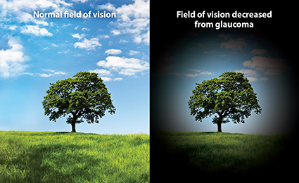

We found that they did in fact update their website : <http://www.glaucoma-association.com/> . Unfortunately, it was not much better. They did take our suggestions mentioned above and put the languages in a different section at the top. If you use a screen reader, it reads through every single language mentioned at the top before continuing down the page. My partner, Mike is actually fluent in German and also mentioned that these new translations are much less accurate. Instead of saying “my sight is fine, why test for glaucoma?”, it says “my appearance is fine, why test for glaucoma?” These are obviously two very different meanings. Unfortunately the International Glaucoma Association is not very effective in convey information to their target audience, both on their previous page and the updated one.